CSI 244 – Networking Project

Scenario:
You are an employee of a consulting firm called IT Network Solutions. Your firm’s responsibilities include ON-SITE inspections for the planning phase of a network installation, including determining:

- What type of network would best suit each particular customer (e.g., peer-to peer or client/server )
- If the customer needs a LAN and/or a WAN
- What type of network topology will best suit the customer
- Which cabling media will meet the customer’s needs now and in the near future
- Brands of hardware and software needed by the customer and translating that information into the number of servers, workstations, and licenses that will serve your customer’s business network and wholly support their business.

As a network administrator assigned to this team, you are being sent to the site of a new business, Mr. Z’s Football Palace, located in Green Bay, Wisconsin. The business sells college and professional football-related merchandise. The business sells to both retail and wholesale customers, so on any given day Mr. Z’s has customers who just walk in off the street as well as buyers purchasing merchandise for numerous stores. Mr. Z plans to be involved in Internet sales, so his network will need to have Internet connectivity. Mr. Z also wants to have his own corporate e-mail server.

His facility in Green Bay will use the first floor for retail and the second floor for management and other non-retail staff (like call center personnel receiving calls from Internet and catalog customers). The basement will be for warehousing inventory. Mr. Z really doesn’t have a server room, just an area in the basement where his current phone system and small Internet connection come into the building behind the stairs. There are stairs connecting each floor on the west side of the building. Retail parking is in the front, while staff parking is in the back, thereby allowing each to easily access the building.

Your engineering responsibility is to design a fully switched network. While a complete professional project would require sales to detail the necessary costs involved, this is not part of your role. To price your network solution include all aspects including network operating systems, application software, TCP/IP architecture, servers, switches, routers (network infrastructure), and all workstations and printers (user devices). Be sure to include productivity software, client operating systems, specific software for the various departments such as anti-virus software, and uninterruptible power supplies. Make sure there are sufficient numbers and types of servers, server racks, cabling, connections, switches, and routers. Your design should allow for a 10% growth in the number of employees on the network (Keep this in mind when researching switches—ensure there are enough ports!).

Make sure you ask your instructor many questions (e.g., how many users can use one server, or can you double up services on one device, or when should services be isolated to themselves?). YOUR DELIVERABLES WILL NOT INCLUDE POS: “Point-of-sale” software or hardware is too specialized, and won’t be covered in this project.

Mr. Z’s Football Palace will employ 86 people. Their roles break down as follows:

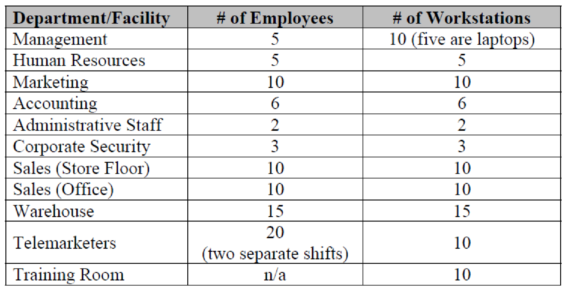

Tools used to complete project

- Microsoft Word, Excel, and PowerPoint.

Each section will be graded based on the following rubric.

- Provide a complete list of equipment. This should include the following:
  - Specifications on each product that was selected.
  - Create a spreadsheet that will include all product description, quantity, pricing, extended pricing.

- Provide a proposal that introduces your company as well as:
  - A general description of what type of equipment you are providing
  - Type of network topology you are implementing.
  - Cost of the project.

- Fulfilled all requirements requested by Mr. Z’s Football Palace scenario.
- Provide a detailed timeline for the time it will take to install this network.
- You will create a PPT and present your plan. Make sure you can defend all your decisions.

